- Bluebook Page102 August 2019 variant four task:

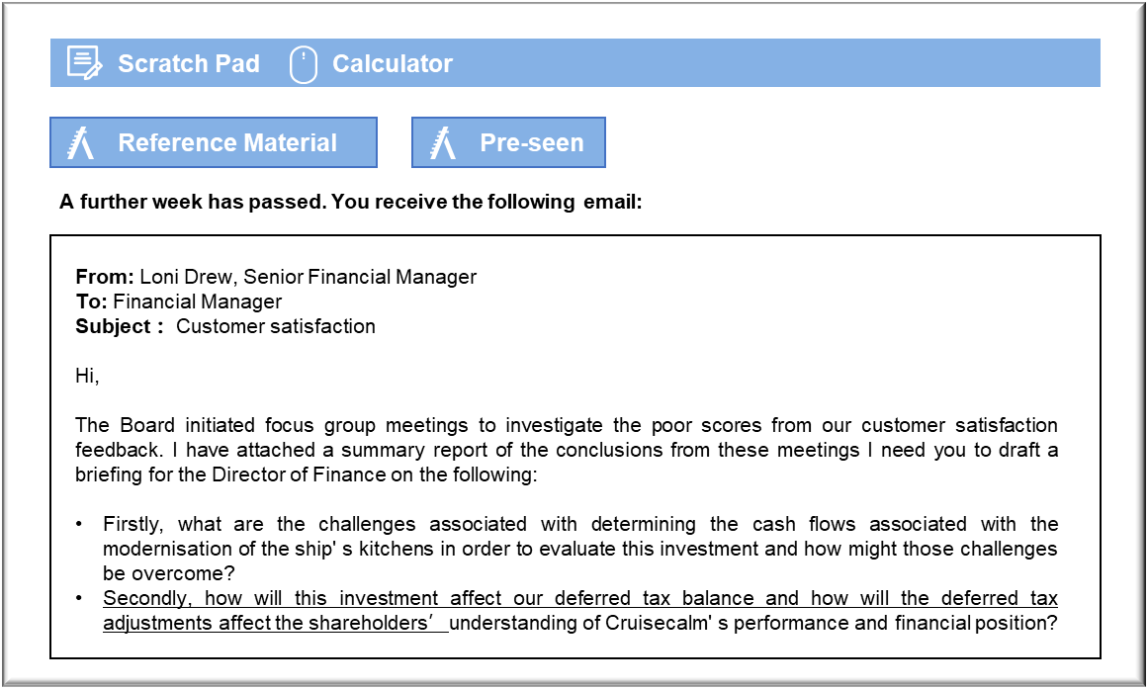MANAGEMENT CASE STUDY AUGUST 2019 EXAM ANSWERS

Variant4 Task3
These answers have been provided by CIMA for information purposes only. The answers created are indicative of a response that could be given by a good candidate. They are not to be considered exhaustive, and other appropriate relevant responses would receive credit.

CIMA will not accept challenges to these answers on the basis of academic judgement.

Requirement 1: Cash flows
The biggest challenge will be in predicting the revenues that this investment will generate, if any.
The first challenge is in estimating the cash revenues that Cruisecalm will generate from
upgrading its kitchens. The investment will only generate revenues if the new kitchens deliver
the promised improvements in meals and that leads more passengers to book cruises.
Prospective passengers will not necessarily be willing to pay more for a cruise, or even to take one at all, just because Cruisecalm claims that its kitchens have been improved.
One response to that challenge would be to invest the N$10 million to upgrade a single ship that was scheduled to carry a number of repeat passengers. During the cruise, the Guest Services staff could organise some focus groups of repeat and first-time passengers in order to obtain feedback on the meals and, crucially, on whether the food was good enough to have them book a repeat cruise. The facilitator of the focus group should aim to identify the benchmarks against which passengers’ measure the quality of meals served aboard ship. The Head Chef’s belief that Cruisecalm should aim to offer more elaborate meals may be misguided.
The second challenge will be to determine the operating costs associated with this investment, because the purchase of new kitchens will not necessarily be the only factor in preparing meals to the passengers’ satisfaction. Even if the new kitchens are more efficient and offer scope for greater automation, the more ambitious menus may require additional staff time and more expensive ingredients. The additional costs may be difficult to predict because it may require an iterative process, with feedback on the new meals from passengers’ to ensure that satisfaction has improved.
The second challenge might be dealt with by extending the focus group exercise and asking
small numbers of passengers to comment on planned menus. The present ships’ kitchens would not permit the new menus to be tested on all passengers, but they would permit small batches of improved meals to be prepared for passengers to sample and comment on. If a range of changes can be tested over the course of a cruise, say, then it might be possible to establish just how much additional expense will be required in terms of labour and ingredients.

Requirement 2: Deferred tax
The impact on deferred tax depends on whether there is a difference between the, manner in which tax depreciation is charged in comparison to accounting depreciation in Norland. The financial statements suggest that there is. Cruisecalm’s statement of financial position shows that it has a liability for deferred tax, which suggests that the rate of tax depreciation could be higher than the rate at which Cruisecalm depreciates its property, plant and equipment (PPE) for accounting purposes. The fact that the 31 December 2019 liability was significantly more than the previous year’s comparative in a year in which the net book value of PPE increased further confirms that possibility.
The deferred tax balance will have to be updated in line with the requirements of IAS 12 Income Taxes. The investment will result in an inflated tax depreciation allowance that will exceed the depreciation charge, which will create an originating temporary difference. The originating temporary difference will be multiplied by the tax rates that are expected to apply when the temporary difference reverses, which will probably be estimated by assuming that the current rate will continue into the future.
The increase in deferred tax, arising from the originating temporary difference, will have the effect of increasing the tax expense for the year. While that will make the tax expense higher than the tax charged on profits for the year, it will have the effect of making the tax expense for the year ended 30 April 2020 a more realistic reflection of the economic reality. Most of the profitability ratios that the shareholders are likely to calculate rely on performance figures that are gross of tax in any case and so many measures of performance will be unaffected.
The statement of financial position will show the increased deferred tax liability as a non-current liability. That will have the effect of increasing the gearing ratio, which many shareholders will use to understand the manner in which Cruisecalm is funded. Even though deferred tax is not a loan, it could be said to recognise the fact that tax law permits the payment of tax to be postponed.
This will increase capital employed, so the return on capital employed will be reduced, even
though the operating profit figure will not be affected.
Note: Credit was awarded for relevant discussion of the news report in the pre-seen that
described the high rate of tax depreciation on PPE in Norland.

